Current measurement and analysing Data using Joulescope
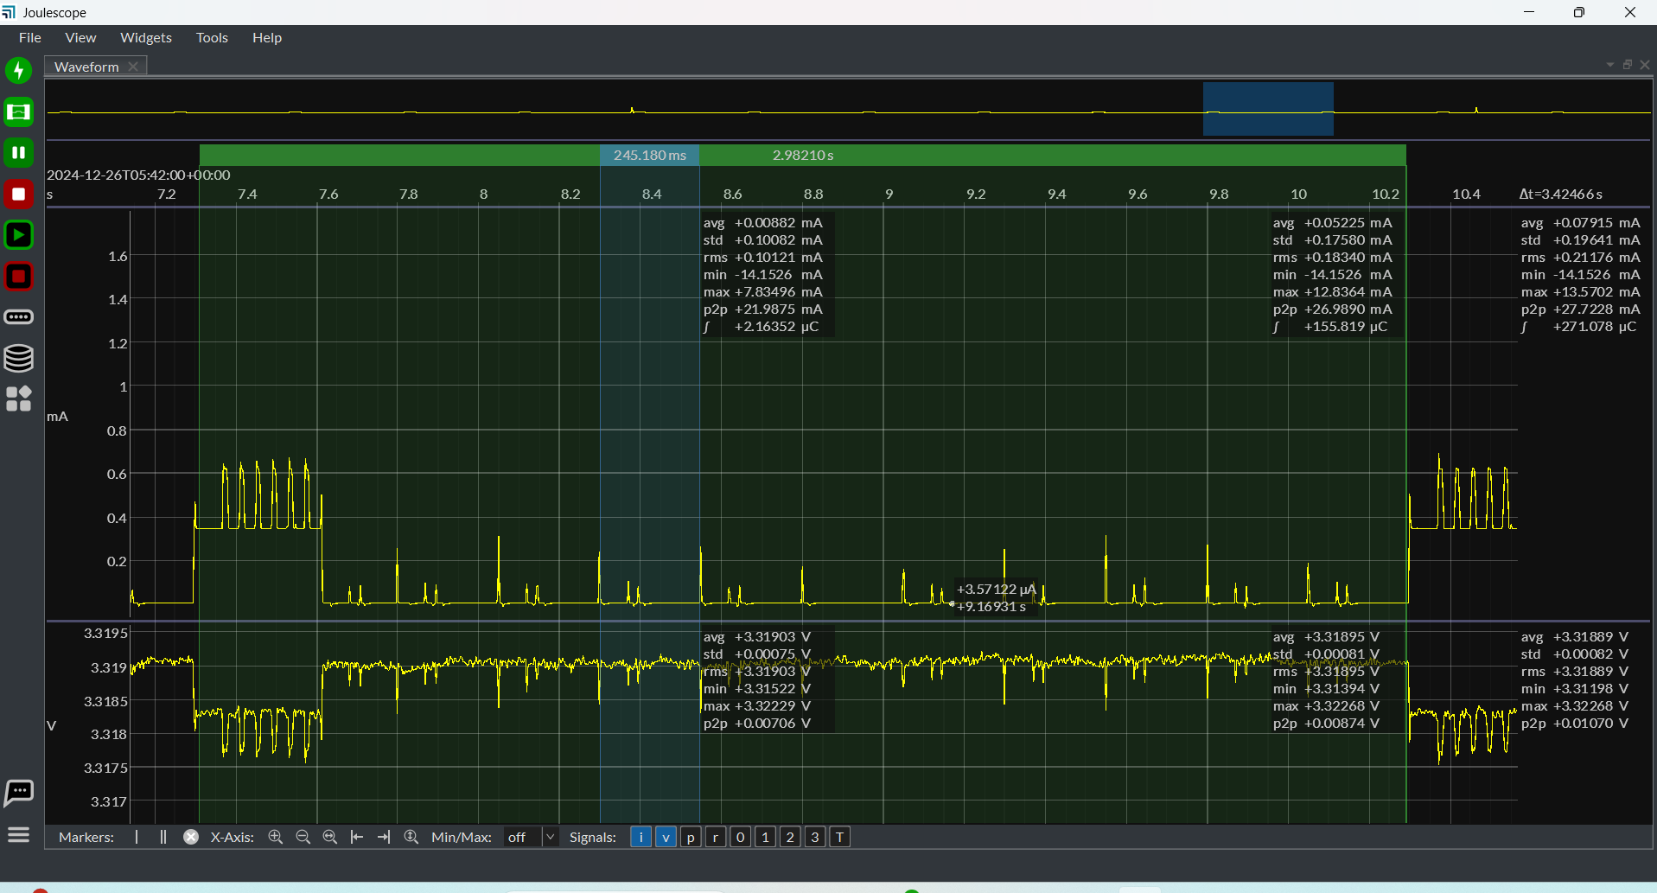
Above is the IR and LF Rx interval
The peak below blue oval is IR Rx without IR and the small peaks are lf rx enable intervals
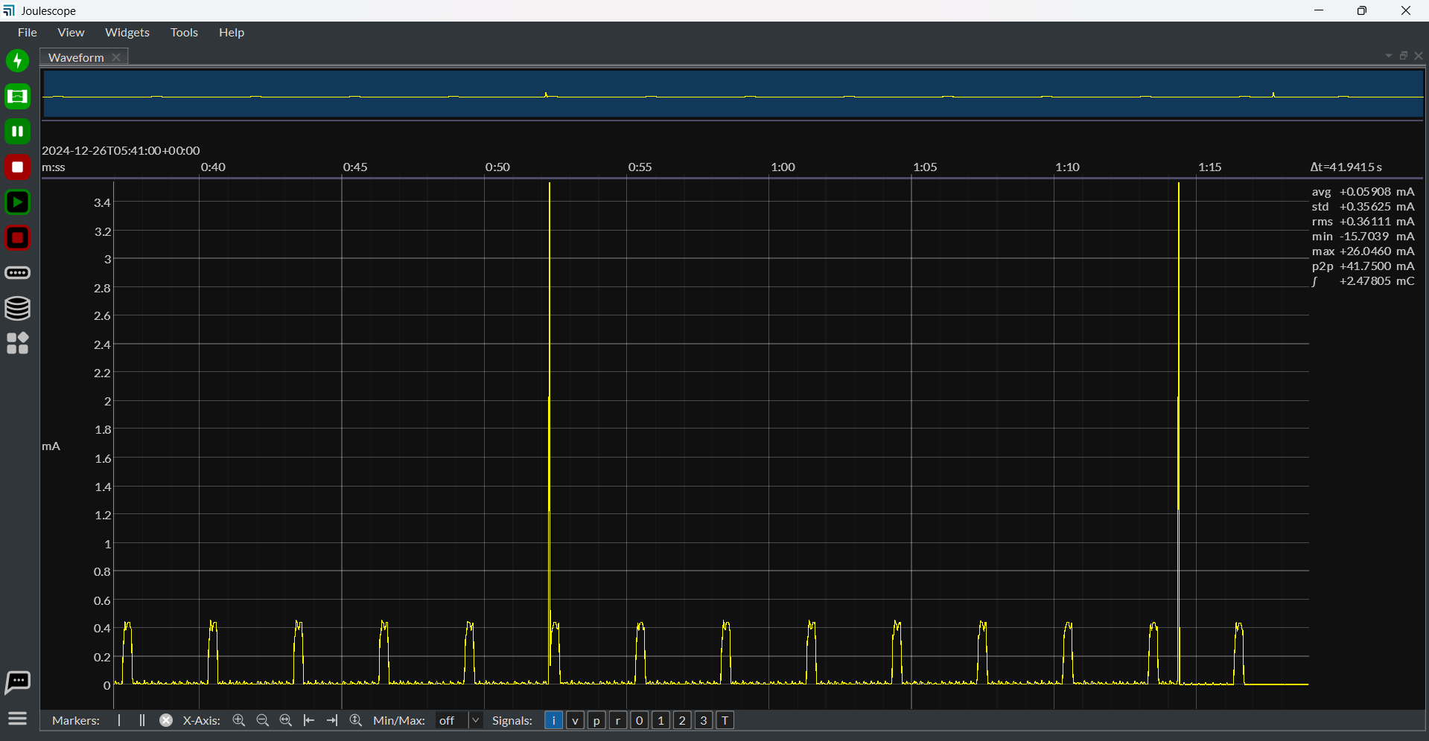
The taller peak is paging pattern without response

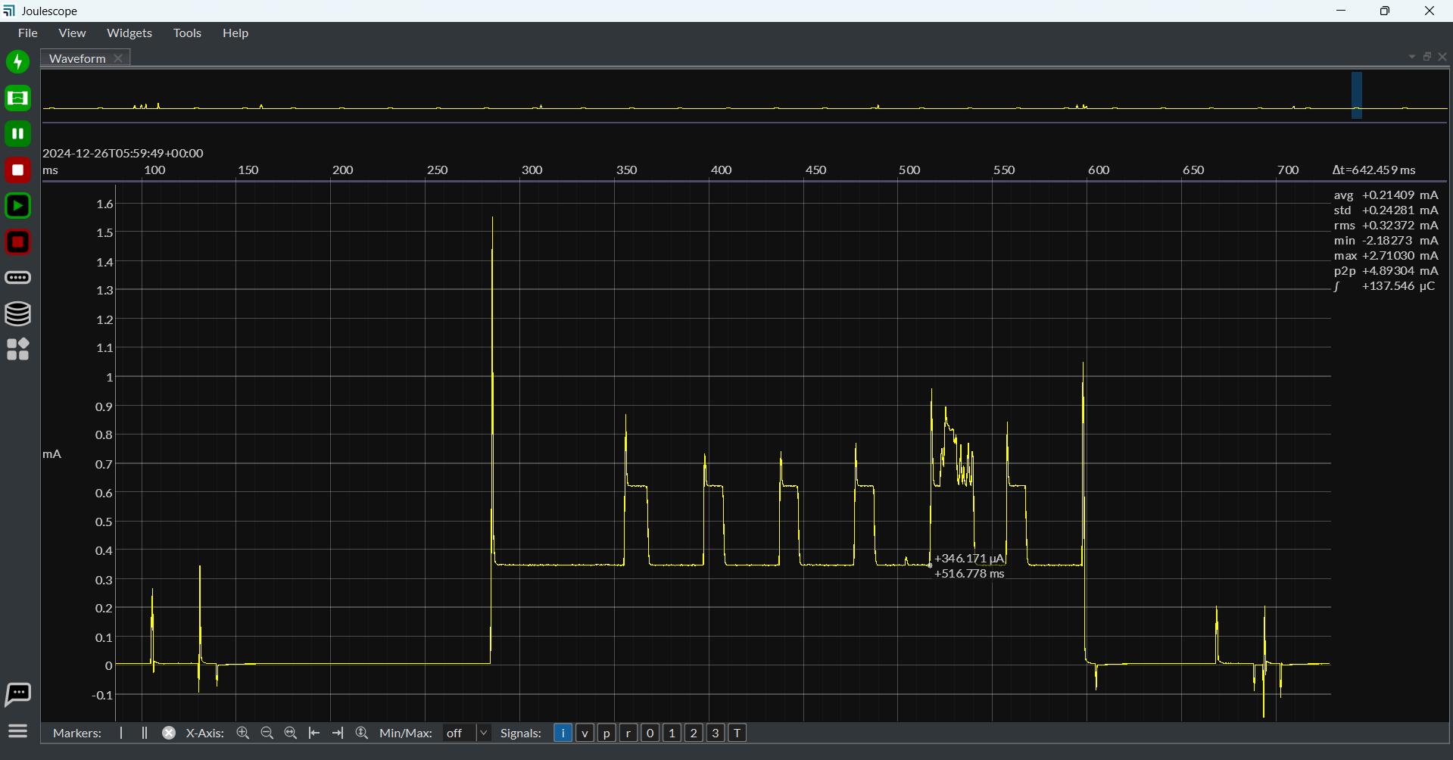
IR received on E profile

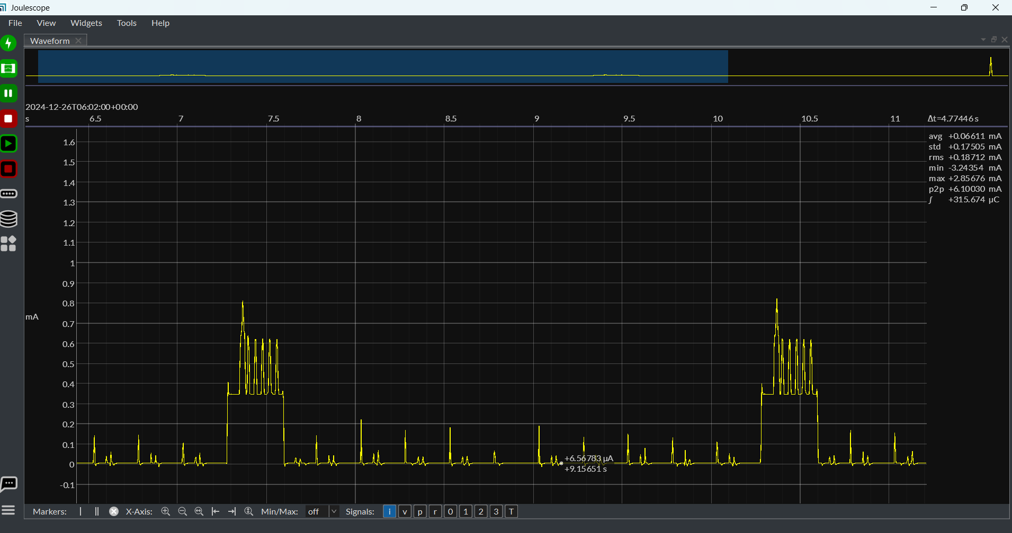
IR Captured in A profile after changing Monitor profile from E to A

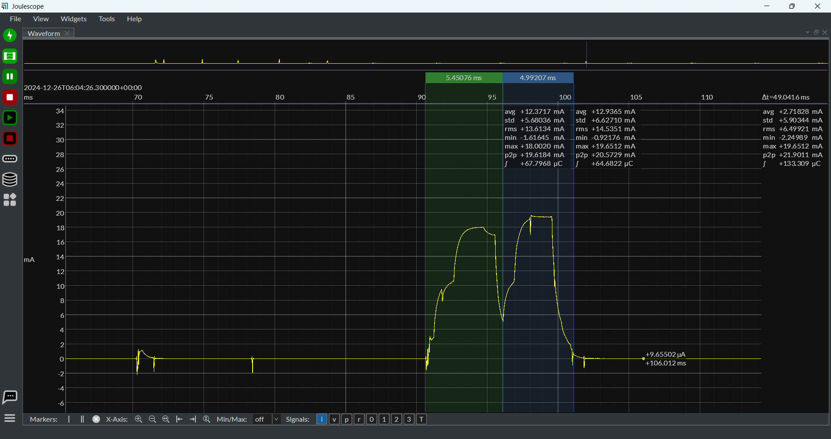
Location pattern, First half in Green marker is Tx, second half in Blue Marker is Rx

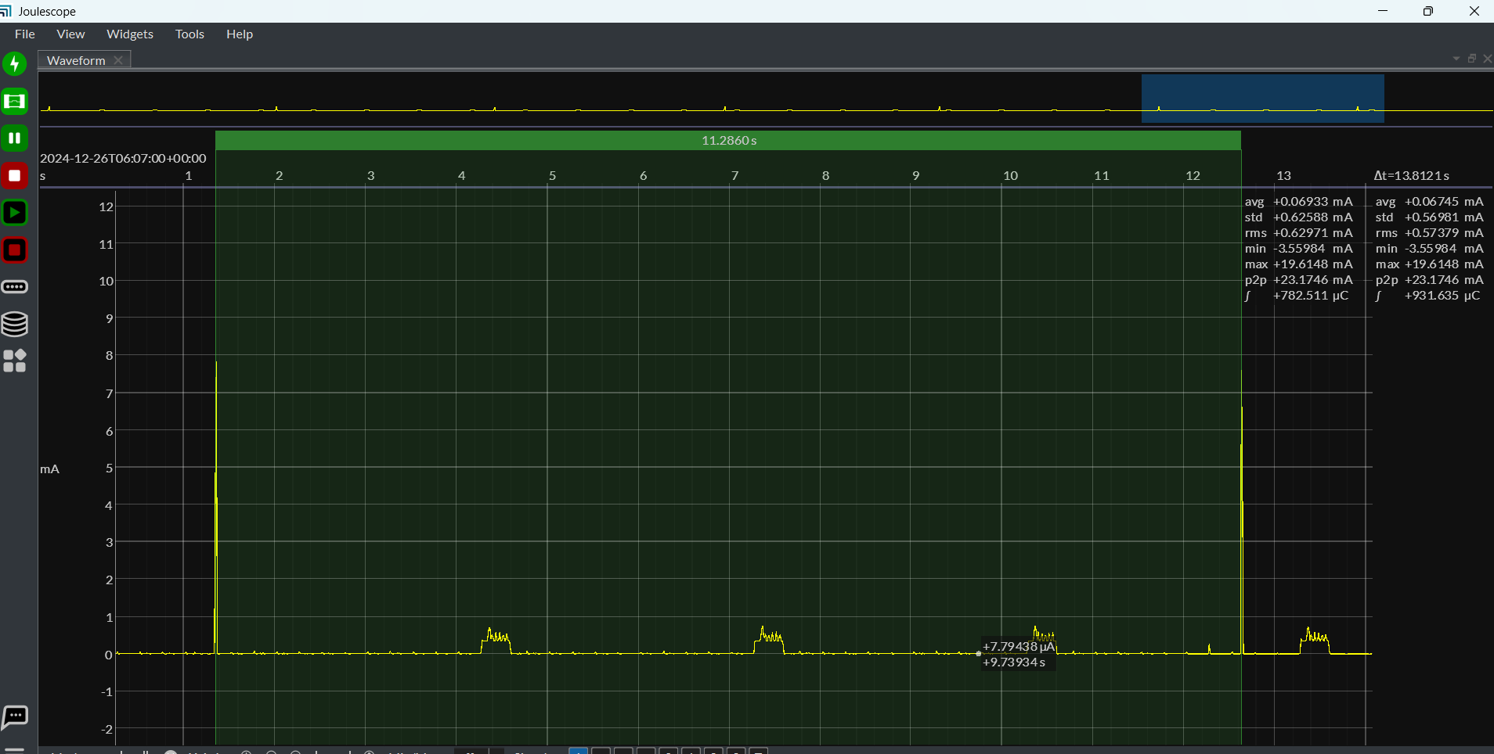
Location packets for every 12 secs when IR Reporting interval is 12sec
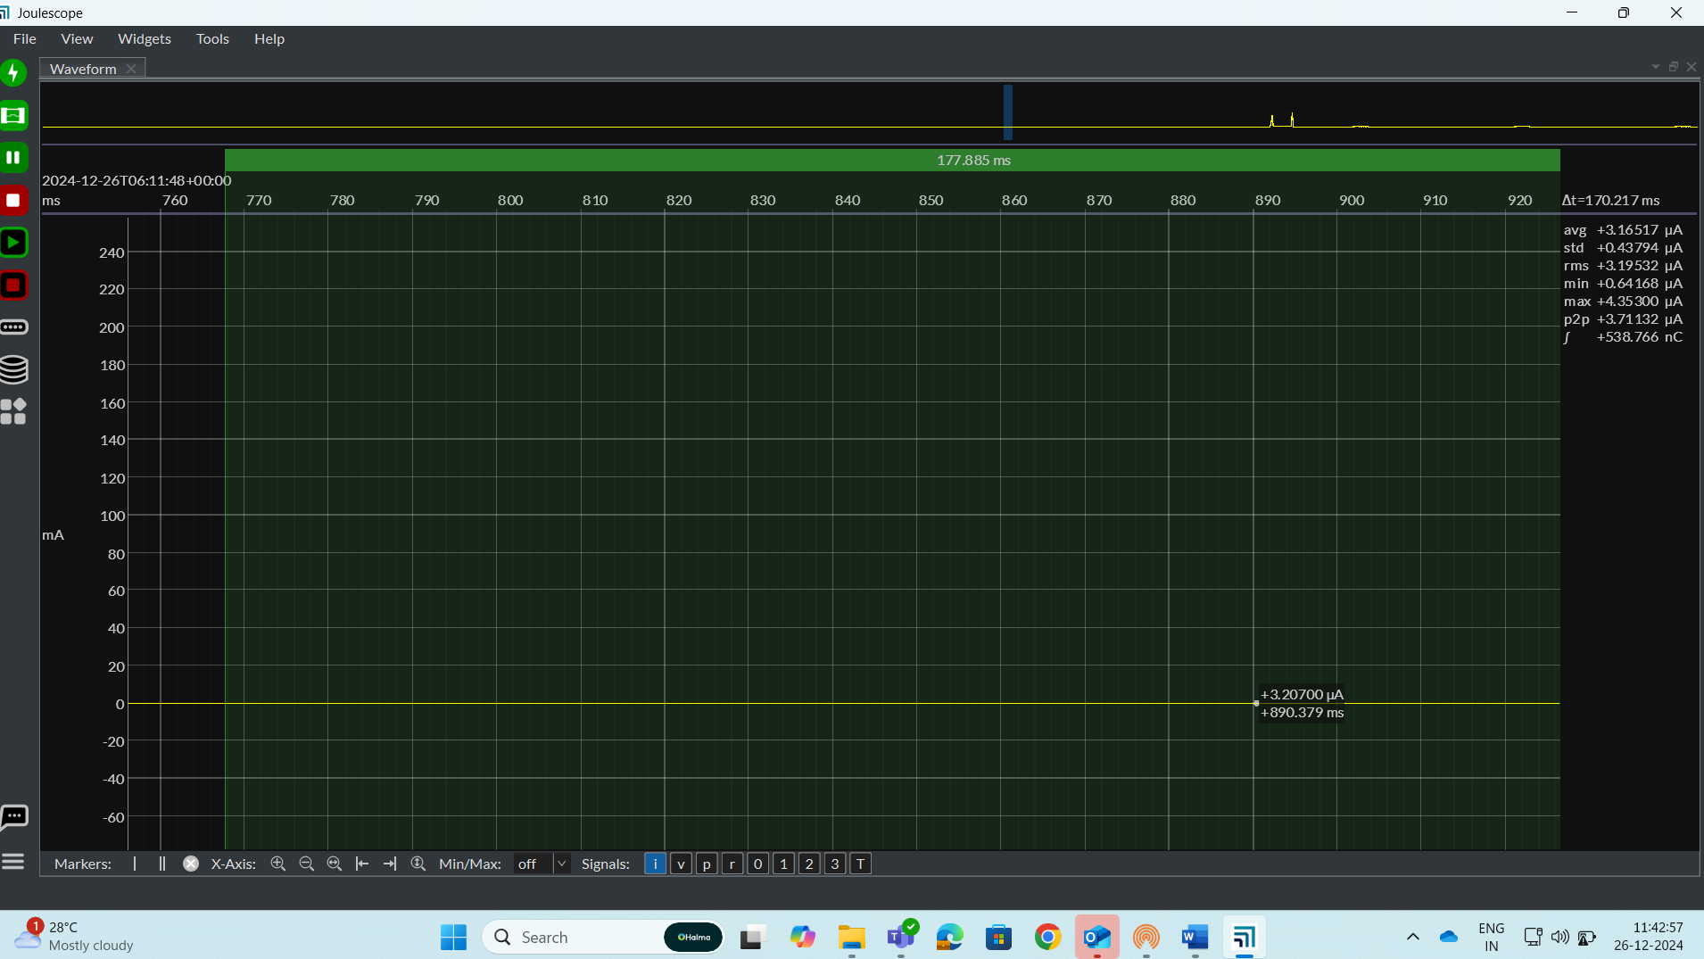
Sleep current of around 3uA
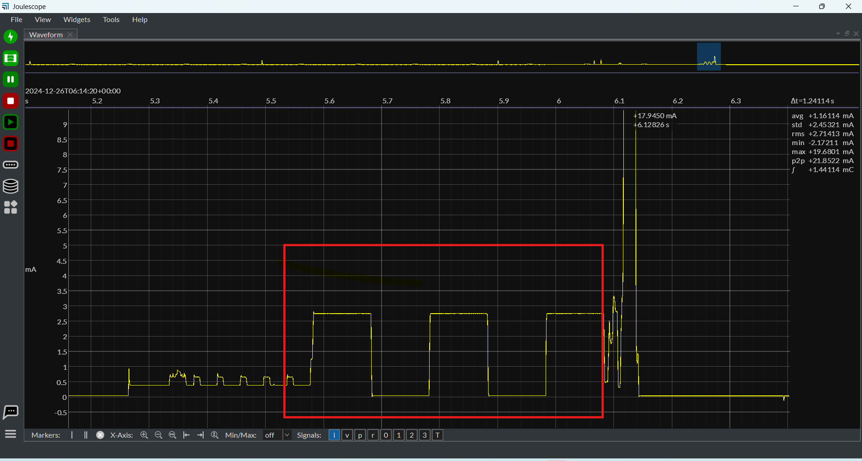
LED Pattern while entering factory sleep by press and hold any key for 6 sec in Staff tag, and factory sleep can be entered only once after flashing and it wont work once you wake it up
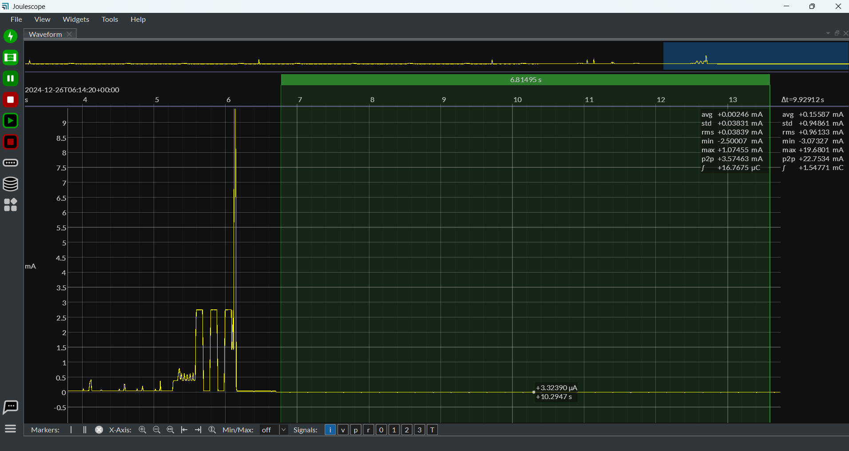
Factory sleep current 2.5uA

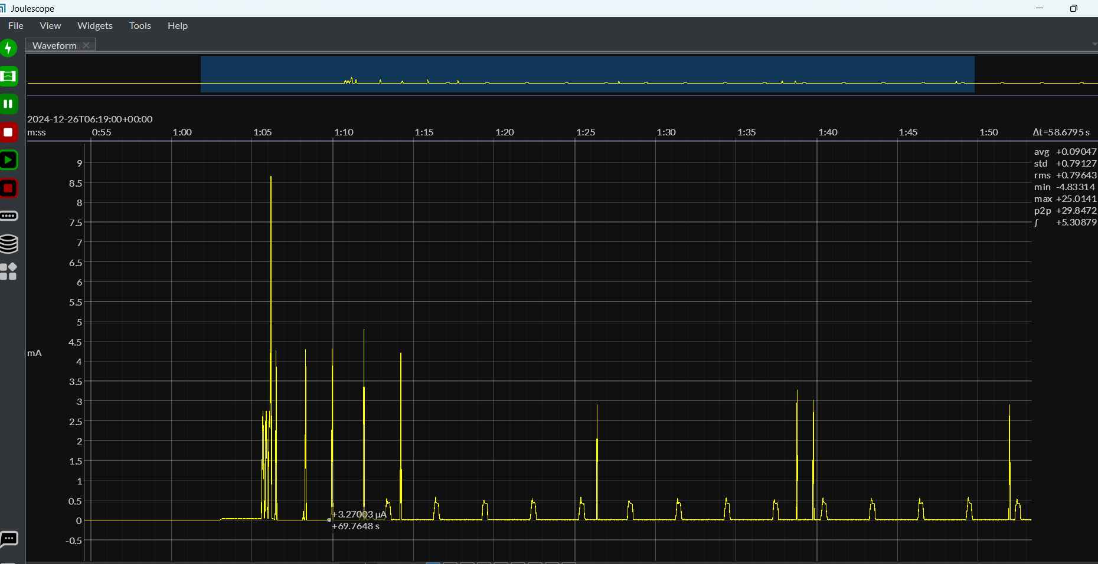
Wakeup from Factory sleep, first peak is waking up from factory sleep, second threes peaks are paging packets, next peak is Location data sent to star
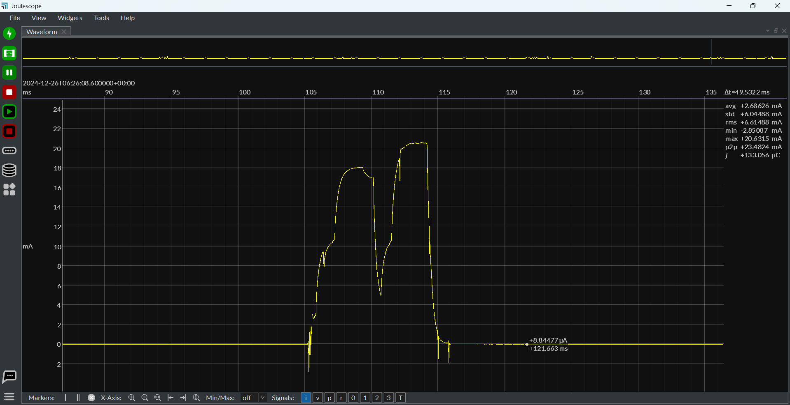
Retry 1 when Star is not reachable, Tx is smaller than Rx
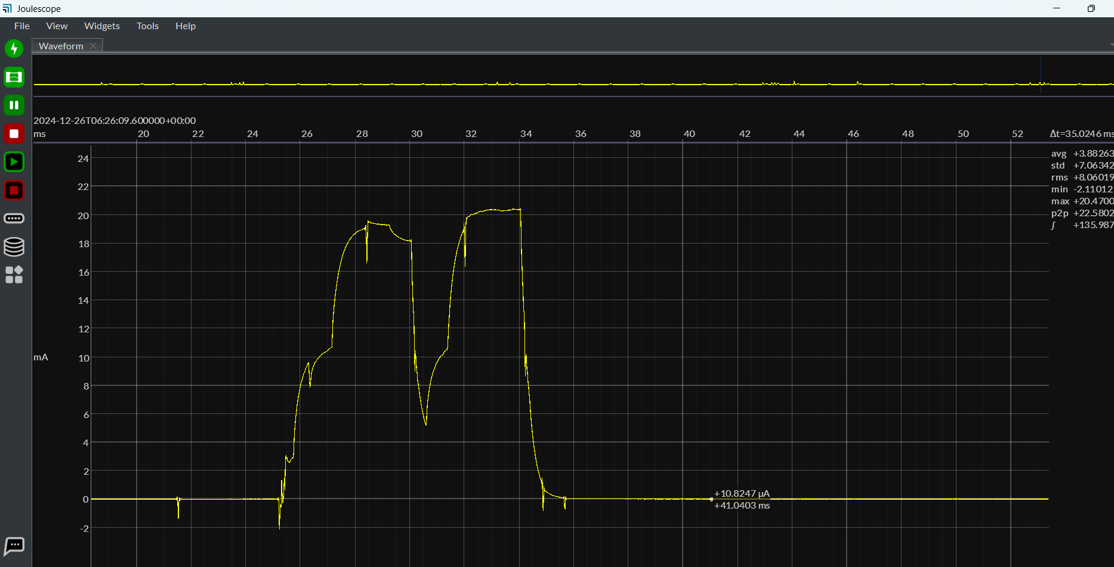
Retry 2 when Star is not reachable, Tx is almost as Rx

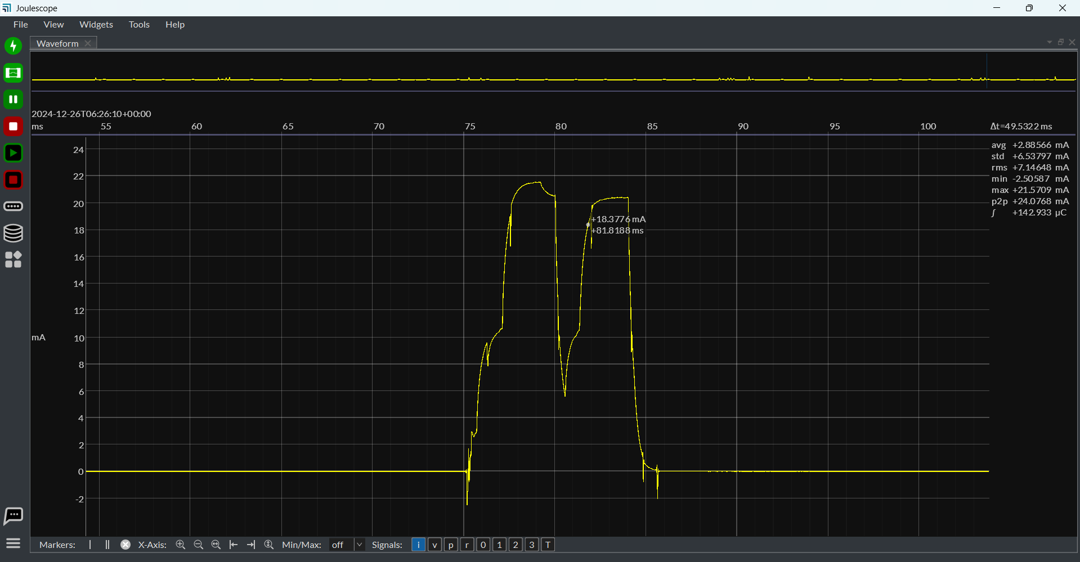
Retry 3, Tx is bigger than Rx, (Pseudo sync process where in tag tries for 3 times with location packet later it enters to paging)
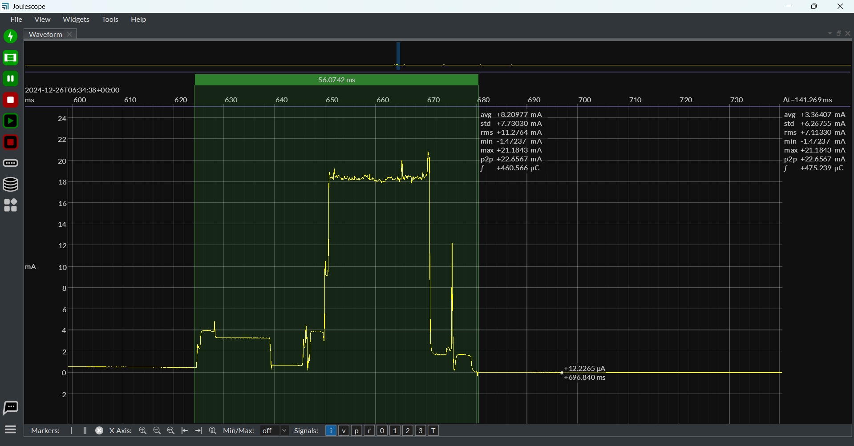
Battery measurement pattern, it comes for every one hour once in normal mode
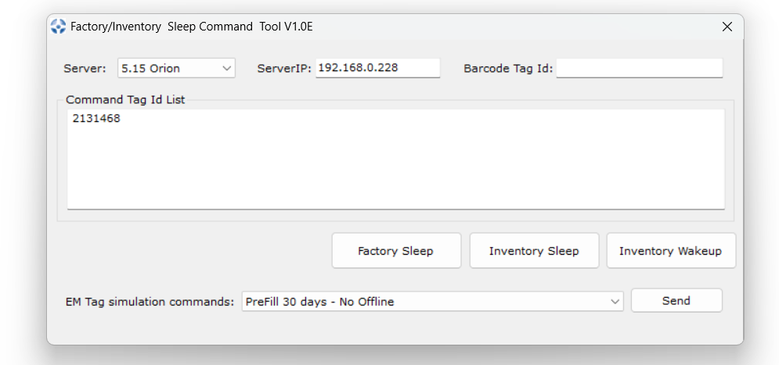
Entering to inventory sleep using tool, Password is Inven<>$!.

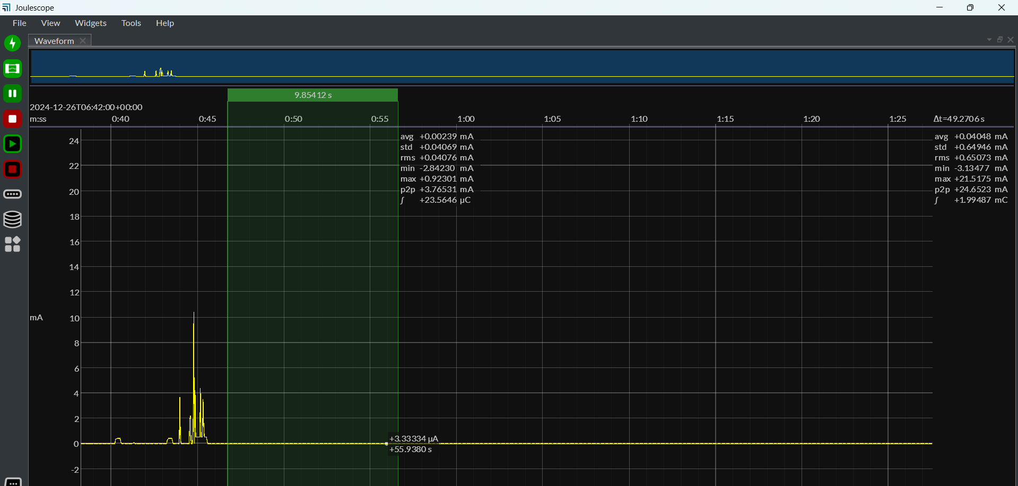
Entering to Inventory sleep using tool, current is 2.3uA. Tag can be woken up by pressing any key for 3 seconds, or by using Inventory sleep tool also
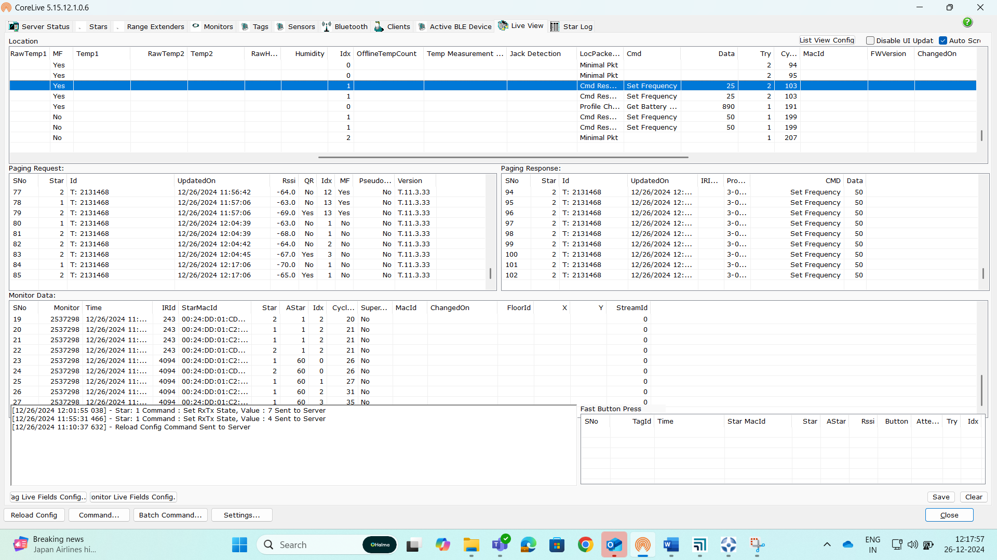
While entering into Inventory sleep, frequency will be set to 25 and while waking up frequency will be set to 50
If we wake up via tool, tag will wake up only after 4 hrs, otherwise we can wakr it up immediately by pressing the key for 3 secs
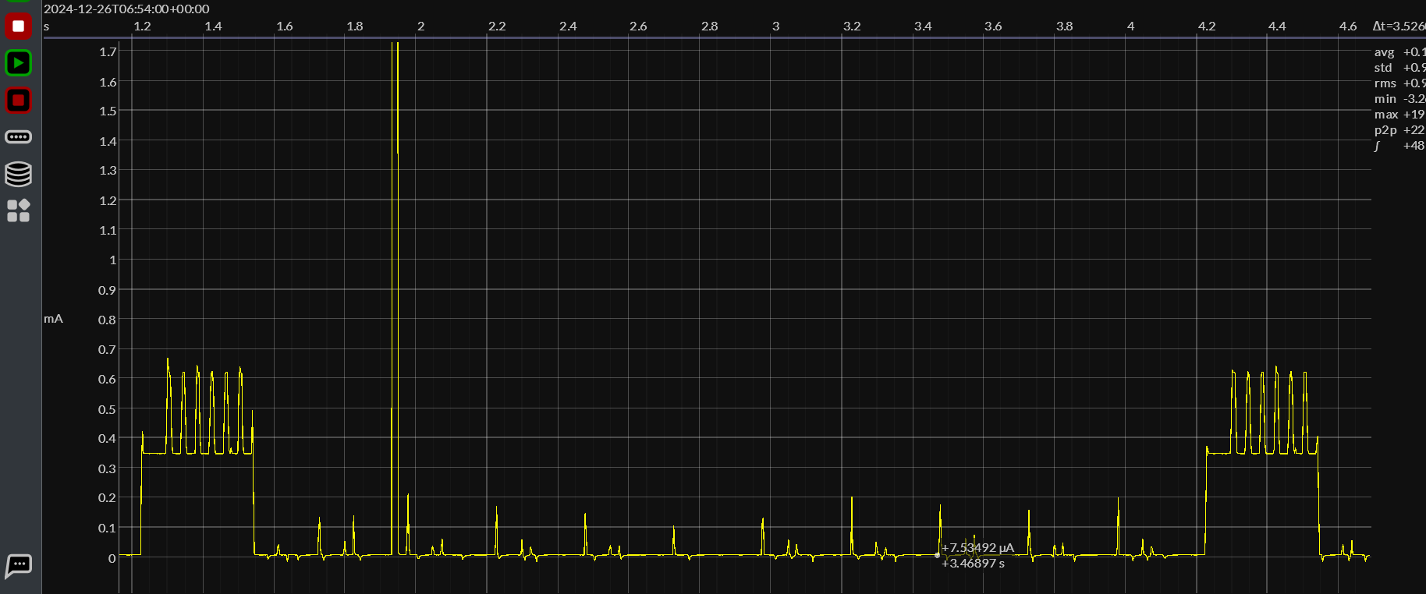
When LF-RX is Enable in tag profile
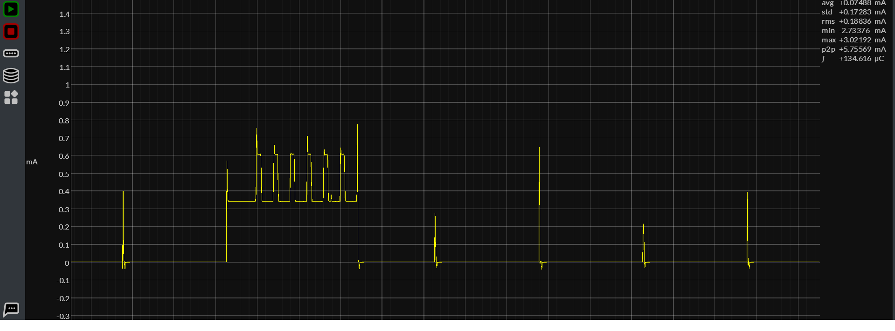
When LF-RX is Disable in tag profile

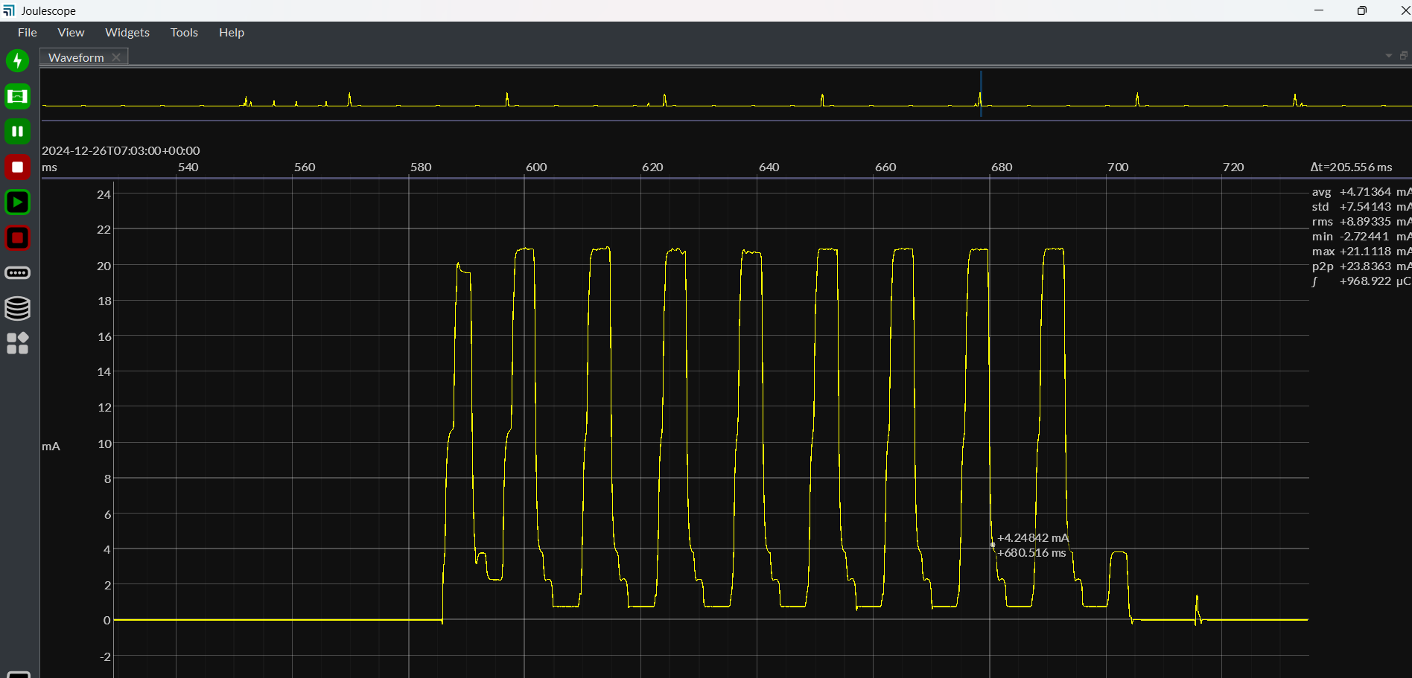
OTA upgrade packets, total 8 packets at once for orion and 4 packets for Pegasus
Here total 9 peaks are there and first peak is beacon peak and next eight are for OTA
For Star Id less than 144, star beacon will be sent in the beginning of OTA and for Star ID greater than 144 it will be sent after 8 packets of OTA
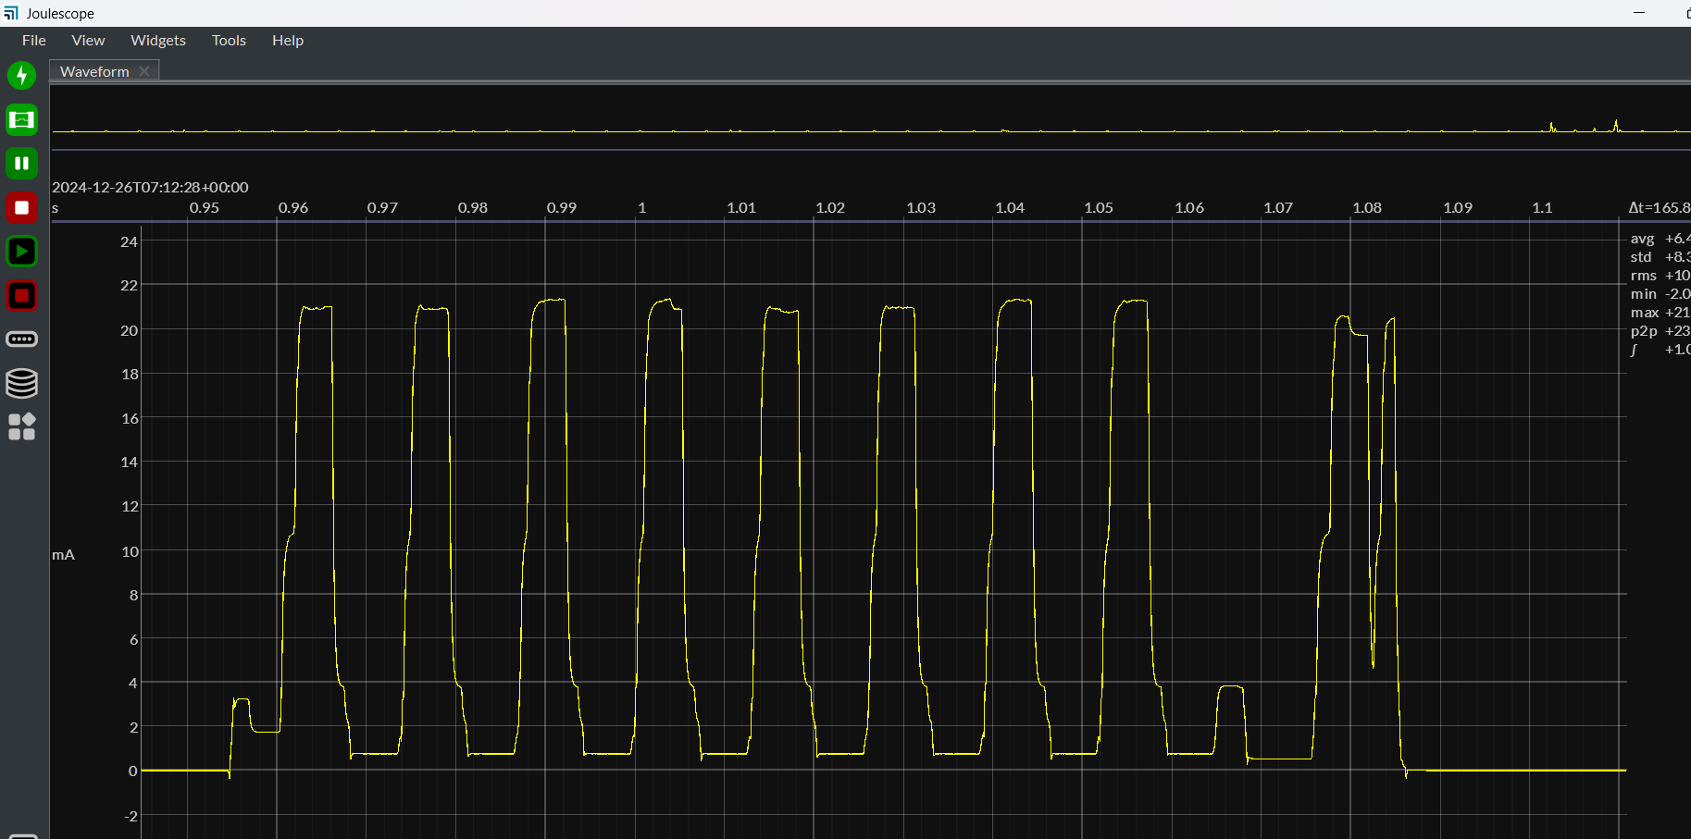
For star ID above 144

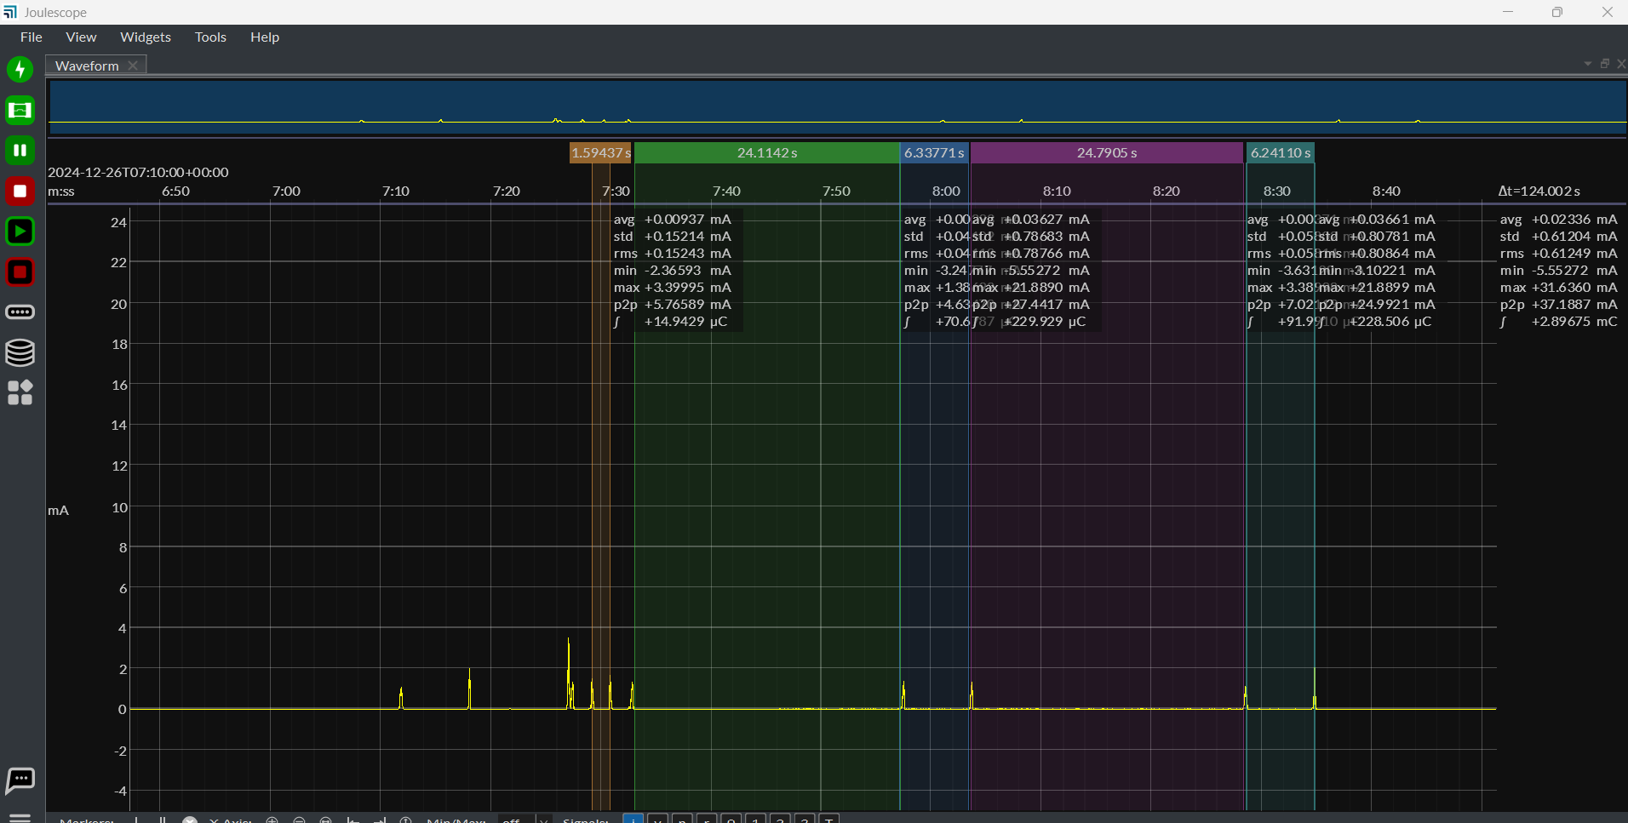
In Async mode, paging data will be sent once in 1.5 sec for three times then for 24 secs then for 6 secs
Patten is like 1.5 – 1.5 – 1.5 – 24 – 6 – 24- 6 ……..
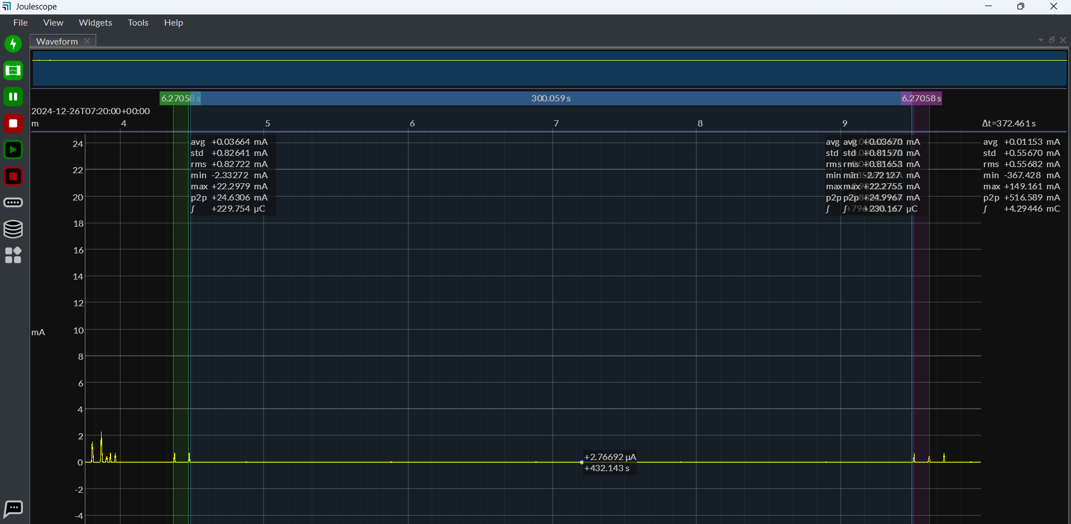
Paging pattern in ASYNC mode in no motion
6 sec – 5min – 6 sec- 6sec -5 min

